SSD will describe the

* BP Solution Diagram
* Solution Description.
* Object Model Diagram. The process/objects to be created consumed using
* Running and avg time per case info. Scheduling
* Alerts that will be triggered on specific scenarios.
* Outputs.

1.2 Robotic Resource Requirement

The process will be executed three time per day and require a maximum of one running session. The first run will be at 9:15, second at 12:15 and third at 15:15.

Current volumes 600 per day

Expected future volumes 1200 per day

Daily System Availability: 24x7x365

Average expected automated case handing time 5 seconds.

This provides a processing capacity of 720 cases per hour

Show process names, systems object that need to be created, utility objects that have to be used

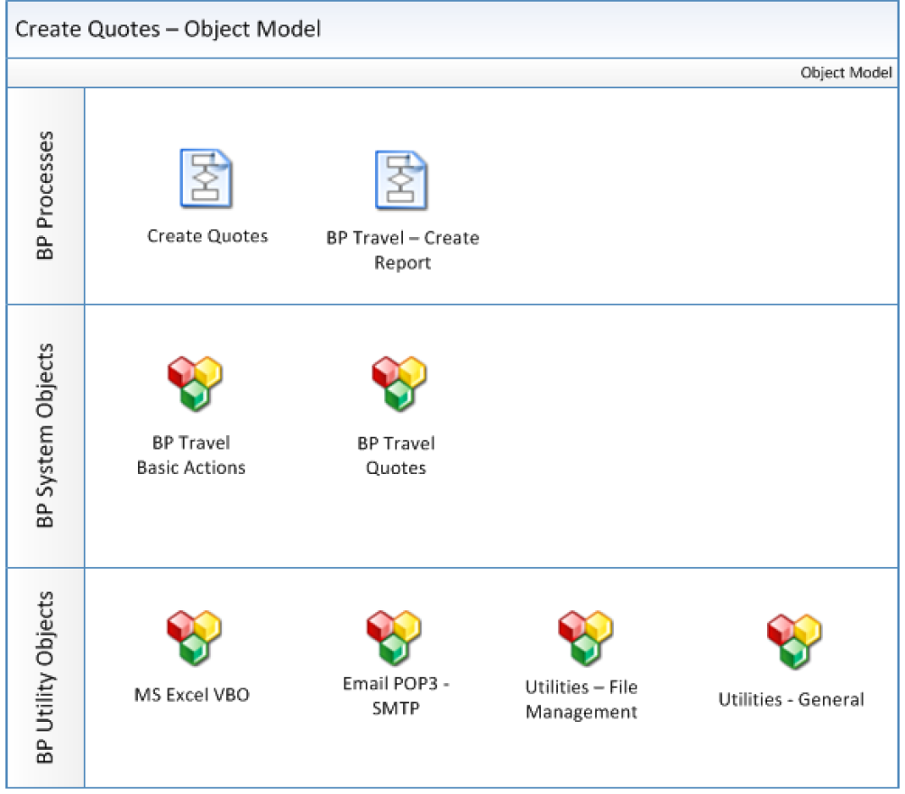

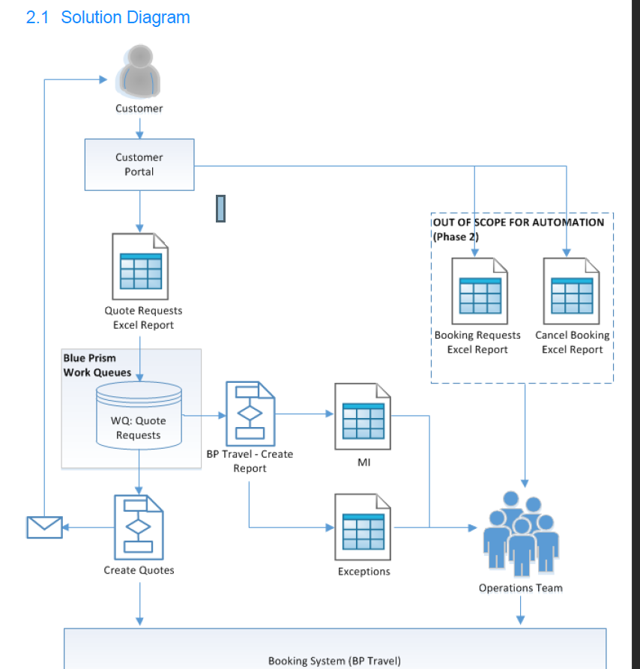

Describe this process in brief.

Also when alerts should be triggered